**Creating an Inverted Index using Hadoop**

**Using Google Cloud Dataproc**

1. You can read about GCP Dataproc and create your free trial account using this URL: <https://cloud.google.com/dataproc/>

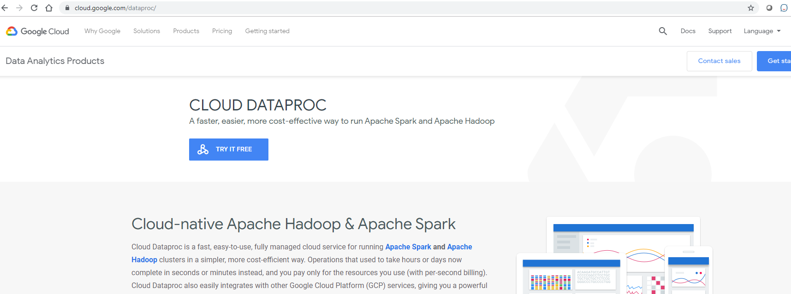

**Note**: the home page for Google Cloud is https://console.cloud.google.com.

**Setting up Your Initial Machine**

Click on “Project” at the top of the window and either create a new project or select an existing one. For new projects choose a name. It may take a while to complete, but eventually you will be redirected to the Google cloud Dashboard.

Google has a large set of APIs, that will appear if you click on the menu immediately to the left of Google Cloud Platform. You will get a list that looks like Figure 2 below. Included in the BIG DATA category are: BigQuery, Pub/Sub, Dataproc, Dataflow, Machine Learning and Genomics. For this exercise we will use Dataproc. Using Dataproc we can quickly create a cluster of compute instances running Hadoop. The alternative to Dataproc would be to individually setup each compute node, install Hadoop on it, set up HDFS, set up master node, etc. Dataproc automates this grueling process for us. Follow the instructions below to create a Hadoop cluster using Dataproc.

1

**Creating a Hadoop Cluster on Google Cloud Platform**

1. Create a Google Dataproc Cluster. Select **Dataproc** from the navigation list on the left

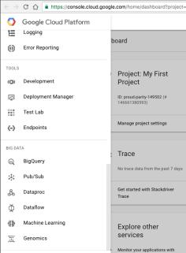

**Figure 2**: Google Cloud Platform APIs

1. If this is the first time you’re using Dataproc then you’ll encounter the error in the below screenshot (Figure 3). This means that your Google cloud account doesn’t have the required API enabled. To enable the API copy the link in the error description and go to it. You will land on a page similar to the one in **Figure 4.** Click the **Enable** button at the top of the page to enable the Dataproc API.

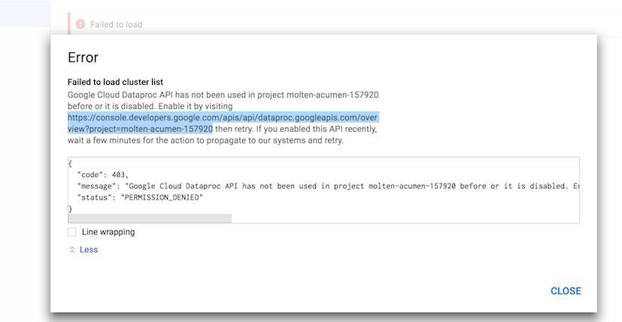

**Figure 3:** Error caused when trying to create a cluster for the first time

2

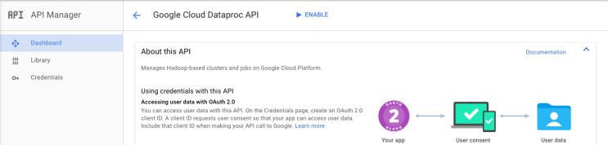

**Figure 4**: Enabling the Dataproc API

1. Once you’ve enabled the API go back to the page where you got the error earlier and reload the page.

You’ll now see a dialog box with a **Create Cluster** button (Figure 5).

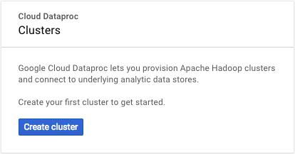

**Figure 5:** This is what you see once the API is enabled

1. Clicking on “**Create Cluster**” will take you to the cluster configuration section (Figure 7). Give any unique name to your cluster and select a **us-west** zone. You need to create a master and 3 worker nodes. Select the default configuration processors **(n1-standard-4 4vCPU 15 GB memory)** for each member and reduce the storage to **32 GB** HDD storage. Leave everything else default and click on

“**Create**”.

If you get an error (Figure 6) saying that you’ve exceeded your quota, reduce the number of worker nodes or choose a Machine Type(for master and worker) with fewer **vCPUs**. In rare cases you may get the error in **Figure 3** again. If so, simply follow the instructions in step 2 again. If all goes well your cluster will be created in a few minutes.

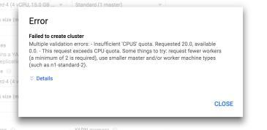

**Figure 6**: Insufficient CPU Quota error

3

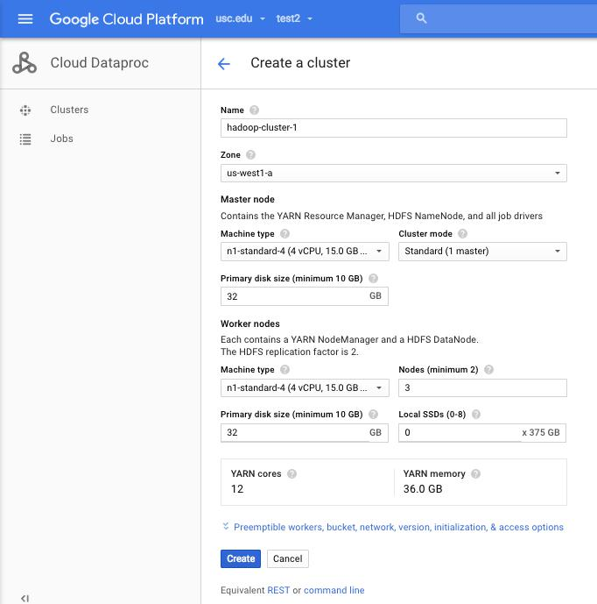

**Figure 7**: Screen for setting up a cluster

1. Now that the cluster is setup we’ll have to configure it a little before we can run jobs on it. Select the cluster you just created from the list of clusters under the cloud Dataproc section on your console. Go to the **VM Instances** tab and click on the **SSH** button next to the instance with the **Master** Role.

If you don’t see the SSH button click the **Refresh** button on the top of the page.

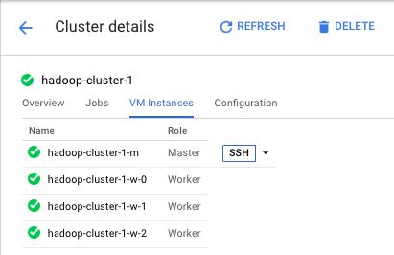

**Figure 8**: SSH into the master node.

4

1. Clicking on the **SSH** button will take you to a Command line Interface(CLI) like an xTerm or Terminal. All the commands in the following steps are to be entered in the CLI.

There is no home directory on HDFS for the current user so set up the user directory on HDFS. So, we’ll have to set this up before proceeding further. (To find out your user name run whoami)

* + hadoop fs -mkdir -p /user/<your username here>

1. Set up environment variables for JAVA and HADOOP_CLASSPATH. Please note that this step has to be done each time you open a new SSH terminal.
   * JAVA_HOME is already set-up. Do not change this.
   * export PATH=${JAVA_HOME}/bin:${PATH}
   * export HADOOP_CLASSPATH=${JAVA_HOME}/lib/tools.jar

To ensure that the environment variables are set, run the command env. You should see the path associated with JAVA_HOME in the PATH variable and a new variable called HADOOP_CLASSPATH as highlighted in the image below.

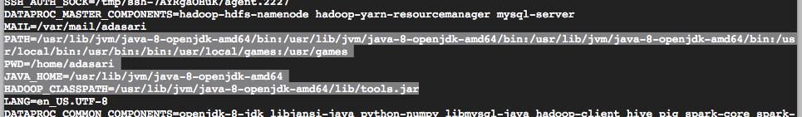

1. Run hadoop fs -ls
2. If there is no error this implies that your cluster was successfully set up. If you do encounter an error it’s most likely due to a missing environment variable or user home directory not being set up right. Retrace steps 1 to 6 to fix this.

**NOTE**:

* Please **disable** the billing for the cluster when you are not using it. Leaving it running will cost extra credits. The cluster is billed based on how many hours it is running and not how much data it is processing. So, if you leave the billing enabled overnight on an idle cluster you will still incur significant charges.
* Click the  on the top left corner in the Google console and go to the **Billing** section. Click the  button next to the project you created initially, and select *disable billing*. Please do this whenever you are not working on the cluster.
* See the **“Enable and Disable Billing account”** section on **page 11** for detailed instructions on how to do this.

5

**Upload Data to the Storage Bucket**

For this project you will be creating an Inverted Index of words occurring in a set of English libraries. These libraries will be placed in a bucket on your Google cloud storage and the Hadoop job will be instructed to read the input from this bucket.

1. Uploading the input data into the bucket

.

* 1. Upload the data files attached with the project
  2. Click on ‘Dataproc’ in the left navigation menu under . Next, locate the address of the default **Google cloud storage staging** bucket for your cluster. Underlined in blue in Figure-9 below. If you’ve previously disabled billing, you need to re-enable it before you can upload the data. Refer to the **“Enable and Disable Billing account”** section to see how to do this.

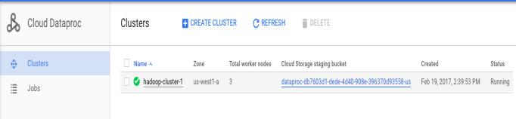

**Figure 9:** The default Cloud Storage bucket.

1. Go to the storage section in the left navigation bar select your cluster’s default bucket from the list of buckets. At the top you should see menu items UPLOAD FILES, UPLOAD FOLDER, CREATE FOLDER, etc. Click on the UPLOAD FOLDER button and upload the data folders individually. This will take a while, but there will be a progress bar. You may not see this progress bar as soon as you start the upload but, it will show up eventually.



**Figure 10:** Cloud Storage Bucket.

**Inverted Index Implementation using Map-Reduce**

Now that you have the cluster and the data in place, you need to write the actual code for the job. As of now, Google Cloud allows us to submit jobs via the UI, only if they are packaged as a jar file. The following steps are focussed on submitting a job written in Java via the Cloud console UI.

Refer to the below examples and write a Map-Reduce job in java that creates an Inverted Index given a collection of text files. You can very easily tweak a **word-count example** to create an inverted index instead (**Hint**: Change the mapper to output word **docID** instead of word count and in the reducer use a

**HashMap**).

The example in the following pages explains a Hadoop word count implementation in detail. It takes one text file as input and returns the word count for every word in the file. Refer to the comments in the code for explanation.

7

**The Mapper Class:**

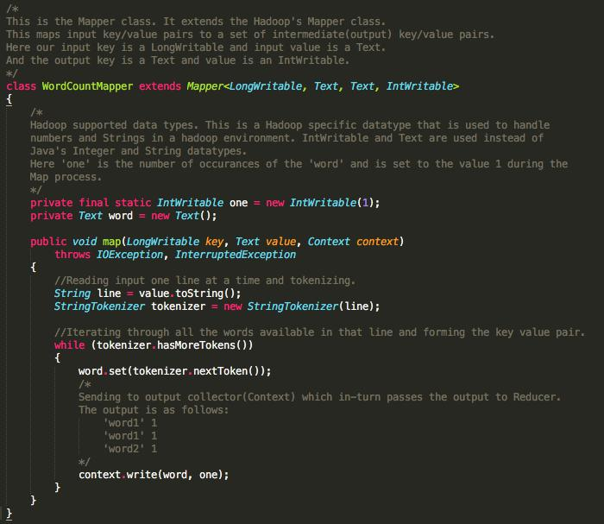

**The Reducer Class:**

8

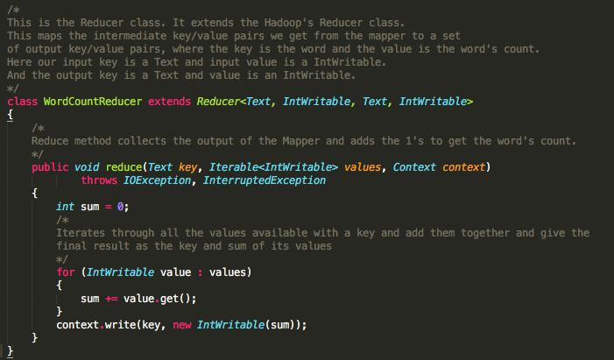

**Main Class**

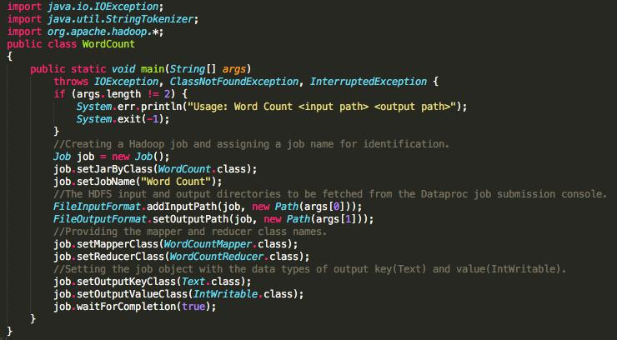

:



DocumentID document

9

.

To write the Hadoop java code you can use the **VI** or **nano** editors that come pre-installed on the master node. You can test your code on the cluster itself. Be sure to use the development data while testing the code. You are expected to write a simple Hadoop job.

**Creating a jar for your code (Sample Example)**

Now that your code for the job is ready we’ll need to run it. The Google Cloud console requires us to upload a Map-Reduce job as a jar file. In the following example the Mapper and Reducer are in the same file called InvertedIndexJob.java.To create a jar for the Java class implemented please follow the instructions below. The following instructions were executed on the cluster’s master node on the Google Cloud.

1. Say your Java Job file is called InvertedIndex.java. Create a JAR as follows:

* hadoop com.sun.tools.javac.Main InvertedIndexJob.java

If you get the following Note you can ignore them

Note: InvertedIndexJob.java uses or overrides a deprecated API.

Note: Recompile with -Xlint:deprecation for details.

* jar cf invertedindex.jar InvertedIndex*.class

Now you have a jar file for your job. You need to place this jar file in the default cloud bucket of your cluster. Just create a folder called JAR on your bucket and upload it to that folder. If you created your jar file on the cluster’s master node itself use the following commands to copy it to the JAR folder.

* hadoop fs -copyFromLocal ./invertedindex.jar
* hadoop fs -cp ./invertedindex.jar gs://dataproc-69070.../JAR

The highlighted part is the default bucket of your cluster. It needs to be prepended by the gs:// to tell the Hadoop environment that it is a bucket and not a regular location on the filesystem.

**Note**: This is not the only way to package your code into a jar file. You can follow any method that willcreate a single jar file that can be uploaded to the google cloud.

**Submitting the Hadoop job to your cluster**

As mentioned before, a job can be submitted in two ways.

1. From the console’s UI.
2. From the command line on the master node.

If you’d like to submit the job via the command line follow the instructions [here](https://hadoop.apache.org/docs/stable/hadoop-mapreduce-client/hadoop-mapreduce-client-core/MapReduceTutorial.html)

https://hadoop.apache.org/docs/stable/hadoop-mapreduce-client/hadoop-mapreduce-client-core/MapReduceTutorial.html

Follow the instructions below to submit a job to the cluster via the console’s UI.

1. Go to the “Jobs” section in the left navigation bar of the Dataproc page and click on “**Submit job**”.

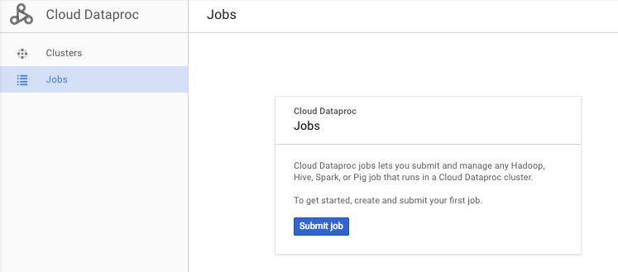

11

**Figure 12**: Dataproc jobs section

1. Fill the job parameters as follows (see Figure 13 for reference):
   * **Cluster**: Select the cluster you created
   * **Job Type**: Hadoop
   * **Jar File**: Full path to the jar file you uploaded earlier to the Google storage bucket. Don’tforget the gs://
   * **Main Class or jar**: The name of the java class you wrote the mapper and reducer in.
   * **Arguments**: This takes two arguments
     1. **Input**: Path to the input data you uploaded
     2. **Output**: Path to the storage bucket followed by a **new** folder name. The folder iscreated during execution. You will get an error if you give the name of an existing folder.
   * Leave the rest at their default settings

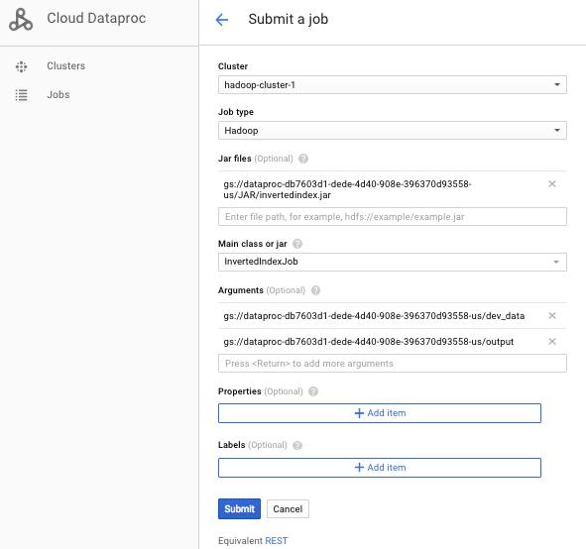

**Figure 13**: Job submission details

1. Submit Job. It will take quite a while. Please be patient. You can see the progress on the job’s status section.

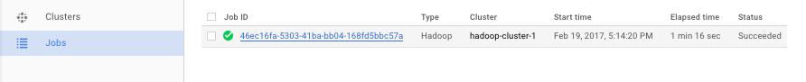

**Figure 14**: Job ID generated. Click it to view the status of the job.

12

**NOTE:** If you encounter a **Java.lang.Interrupted exception** you can safely ignoreit. Your submission will still execute.

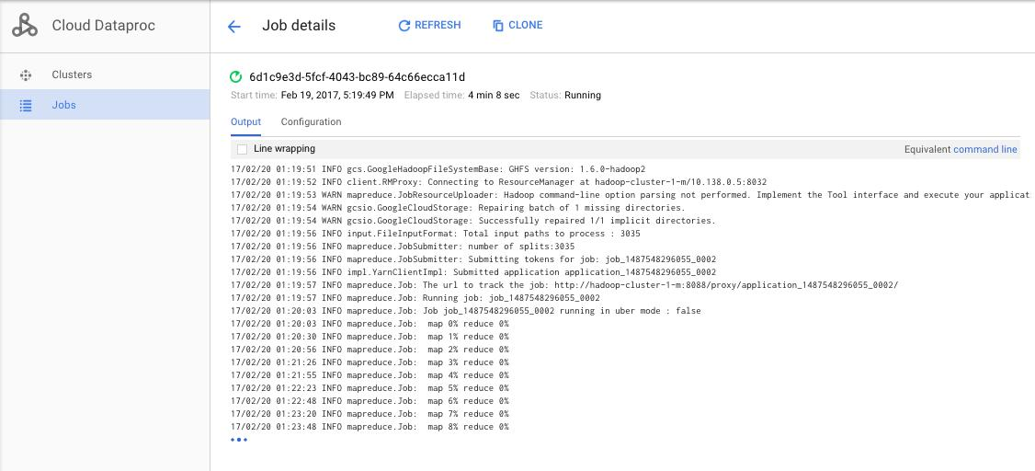

**Figure 14:** Job progress

1. Once the job executes copy all the log entries that were generated to a text file called log.txt. You need to submit this log along with the java code. You need to do this only for the job you run on the full data. No need to submit the logs for the dev_data.
2. The output files will be stored in the output folder on the bucket. If you open this folder you’ll notice that the inverted index is in several segments.(Delete the **_SUCCESS** file in the folder before merging all the output files)

To merge the output files, run the following command in the master nodes command line(SSH)

* hadoop fs -getmerge gs://dataproc-69070458-bbe2-.../output

./output.txt

* hadoop fs -copyFromLocal ./output.txt
* hadoop fs -cp ./output.txt gs://dataproc-69070458-bbe2-.../output.txt

The output.txt file in the bucket contains the full Inverted Index for all the libraries.

Use grep to search for the words mentioned in the submissions section. Using grep is the fastest way to get the entries associated with the words.

|  |  |  |
| --- | --- | --- |
| For example to search for “string” use | ’ fullindex.txt |  |
| grep -w ‘^string |  |

13

**Enabling and Disabling Billing accounts**

We need to disable billing for the project (where the cluster was created) when we are not running the job to save some credits. Follow the steps below to disable and enable the billing for your project:

**Disable Billing:**

1. Click the navigation button on the top left .
2. Navigate to the billing section.
3. Click on Disable billing for the project you created.(See screenshot below)

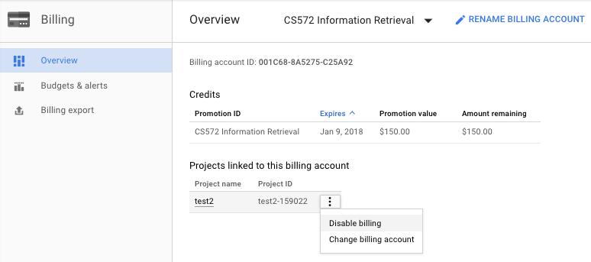

**Figure 15**: Disabling the billing for the cluster.

**Enable Billing:**

**Option 1**: When you navigate to the billing section you will be prompted to select the billing account. Make sure to use your free trial account

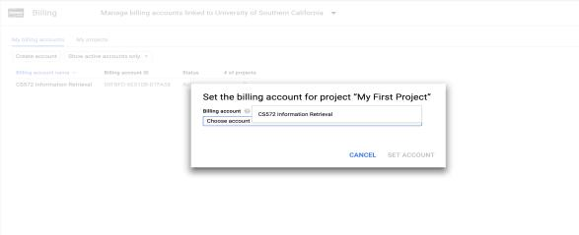

**Figure 16**: Select the account

14

**Option 2:**

1. Navigate to the Dataproc section. You will see a screen similar to the figure below. Click on Enable billing.

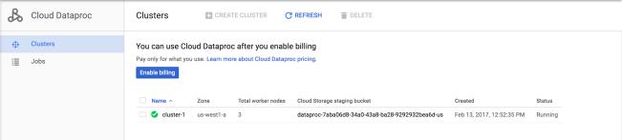

**Figure 17:** Enable billing

**NOTE** : Every time you disable and enable billing for a cluster, the Virtual Machinesin the cluster don’t start by themselves. We need to manually start the VMs. In the VM Instances section of the Cluster you might see all the VM’s of the cluster disabled (See Figure 18). To enable the VM Instances, navigate to the Compute Engine section. Select all the instances corresponding to the cluster you created and click on the START button. Once activated navigate back to the Dataproc section to resume working on the cluster.

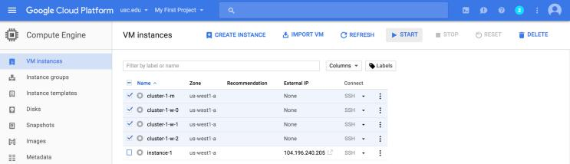

**Figure 18:** Select all virtual machines associated with the cluster.

**Credits Spent:**

To check how much you’ve been charged for your cluster, navigate to the Billing section and click on the project name in the Overview section (see Figure 19 & 20). We suggest you check this section at least once every 24 hours.

15

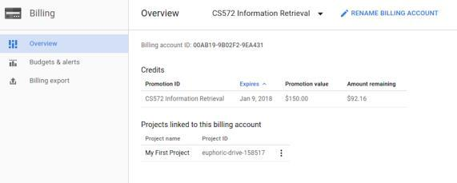

**Figure 19**: Billing Overview section.

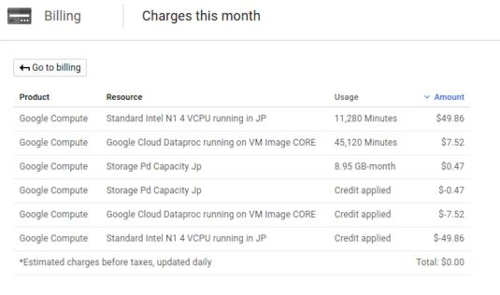

**Figure 20:** Cluster usage cost

**Connecting Your Local Application to GCP DataProc Jobs**

You can check the following URL that provides details on how to connect to your DataProc MapReduce jobs from your local java application: <https://developers.google.com/api-client-library/java/apis/dataproc/v1>